**Experiment 4**

**PART A**

**A.1 Aim**

*To implement heuristic principles and evaluate NMIMS student portal using heuristic evaluation techniques.*

**A.2 Prerequisite**

Understanding of heuristic principles and its evaluation

**A.3 Outcome**

After experimentation, students will be able:

* To understand the evaluation process of heuristic principles for good interface designing
* To generate report of heuristic analysis

**A.4 Theory**

A Heuristic Analysis is an inspection methodology to evaluate a website using a number of evaluation criteria based on a broad set rules of thumb and not necessarily specific usability guidelines. This type of evaluation is usually done on an existing product, or it can be conducted at a later stage in the development of a new product to iron out usability issues before implementation.

**Evaluation Process:**

1. **Establish an appropriate list of heuristics.** You can choose Nielsen 10 heuristics and stepping stones.
2. **Select your evaluators.**Make sure to carefully choose your evaluators. Your evaluators should not be your end users. They should typically be usability experts and preferably with domain expertise
3. **Brief your evaluators** so they know exactly what they are meant to do and cover during their evaluation.
4. **Evaluation phase.**The evaluation generally takes 1-2 hrs, depending on the nature and complexity of your product. The evaluators will use the product freely to gain a feel for the methods of interaction and the scope. They will then identify specific elements that they want to evaluate. The evaluators will carry out another run-through, whilst applying the chosen heuristics to the elements identified during the first phase. The evaluators would focus on individual elements and look at how well they fit in the overall design.
5. **Record problems.**The evaluators must either record problems themselves or you should record them as they carry out their various tasks to track any problems they encounter. Be sure to ask the evaluators to be as detailed and specific as possible when recording problems.

**A.5 Tasks to perform**

* 1. Visit the following link for heuristic evaluation understanding

<https://uxplanet.org/heuristic-evaluation-of-amazon-prime-video-bc09f62cd793>

* 1. Visit the NMIMS student portal. Students will keep in mind heuristic principles while visiting the website. Heuristic principles are:

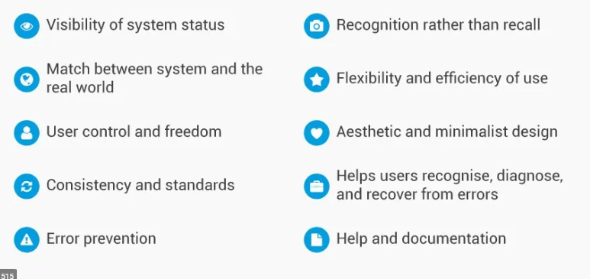

* 1. Evaluate the NMIMS student portal website using heuristic evaluation process.
  2. Generate the heuristic analysis report

**(PART - B)**

(TO BE COMPLETED BY STUDENTS)

(Students must submit the soft copy as per following segments within two hours of the practical)

| Roll.No. : | Name: |
| --- | --- |
| Sem/Year : | Batch: |
| Date of Experiment : | Date of Submission: |
| Grade -- |  |

**B.1: Task assigned:**

1. Login to NMIMS Student portal
2. Navigate main screen to perform following actions
3. Upload the assignment
4. Download the syllabus
5. After performing the actions, logout from the account

**B.2 Evaluate the tasks using heuristic evaluation process:**

***Step 1:*** *Identify evaluators who are very much familiar with the product. Give brief introduction about evaluators.*

(It is a group activity. Group of two people who will be evaluators)

***Step 2:*** *Perform the assigned tasks given in section B.1 using heuristic principles and identify the problems.*

(Students are supposed to give the reason of particular action which does not follow the heuristic principle along with screenshots)

***Step 3:*** *Fill the evaluation sheet*

**Table 1: Evaluation Sheet**

| **Actions** | **Heuristic principle followed/not followed** | **Generated error (if any)** |
| --- | --- | --- |
| Login to NMIMS Student portal |  |  |
| Navigate main screen |  |  |
| Upload assignment |  |  |
| Download syllabus |  |  |
| Logout from the portal |  |  |

(Students are supposed to divide the actions in to sub-actions to perform the tasks. Students will write which heuristic principle is not following for the particular action)

***Step 4:*** *Assign the severity ratings (as given in Table 2) and generate the heuristic analysis report for the performed tasks.*

Severity ratings can be used to allocate the most resources to fix the most serious problems and can also provide a rough estimate of the need for additional usability efforts. The following 0 to 4 rating scale can be used to rate the severity of usability problems. ( visit the link <https://ucabli5.wordpress.com/category/uncategorized/> for analysis report)

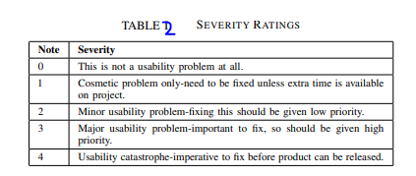

**Table 3: Heuristic Analysis Report**

| **Problems** | **Severity ranking** | **Broad heuristic principle** |
| --- | --- | --- |
|  |  |  |
|  |  |  |

**B.2: Observations and Learnings:**

Write down the possible improvements to the interface based on your web interaction

**B.3: Conclusion:**

(Students must write the conclusion as per the attainment of individual outcome listed above and learning/observation noted in section B.2)